Bayani, Arlene K | BSIT-4A
03 Laboratory Exercise 1  1.1 Step 12 | Network Technology
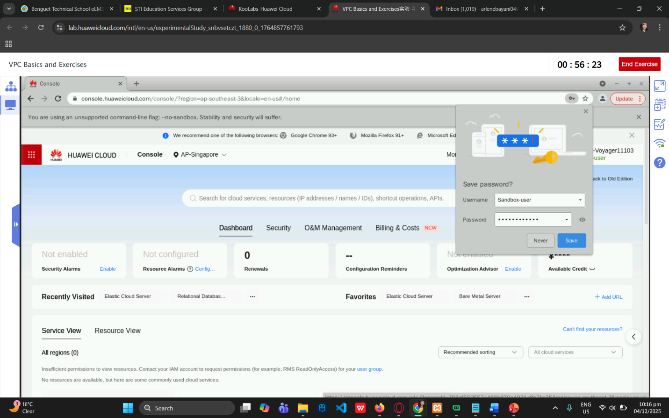
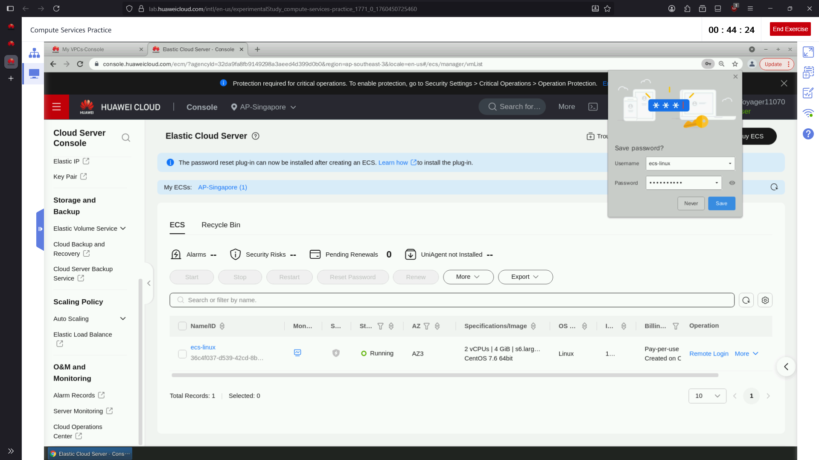
3.2 Step 5


3.3 Step 5&6
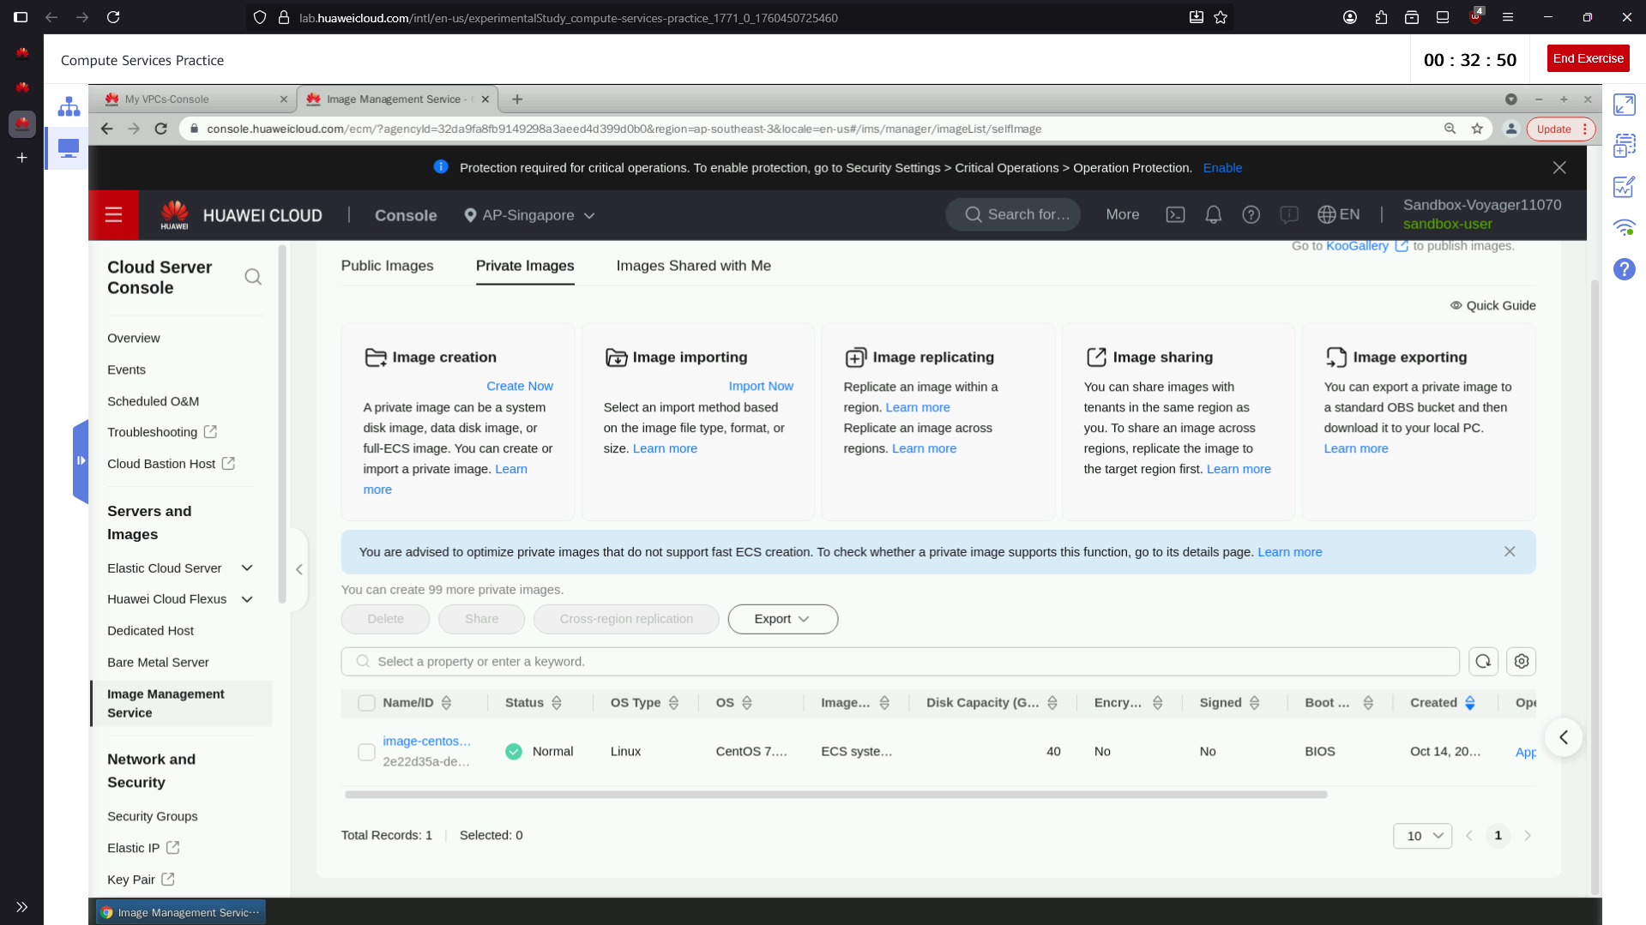
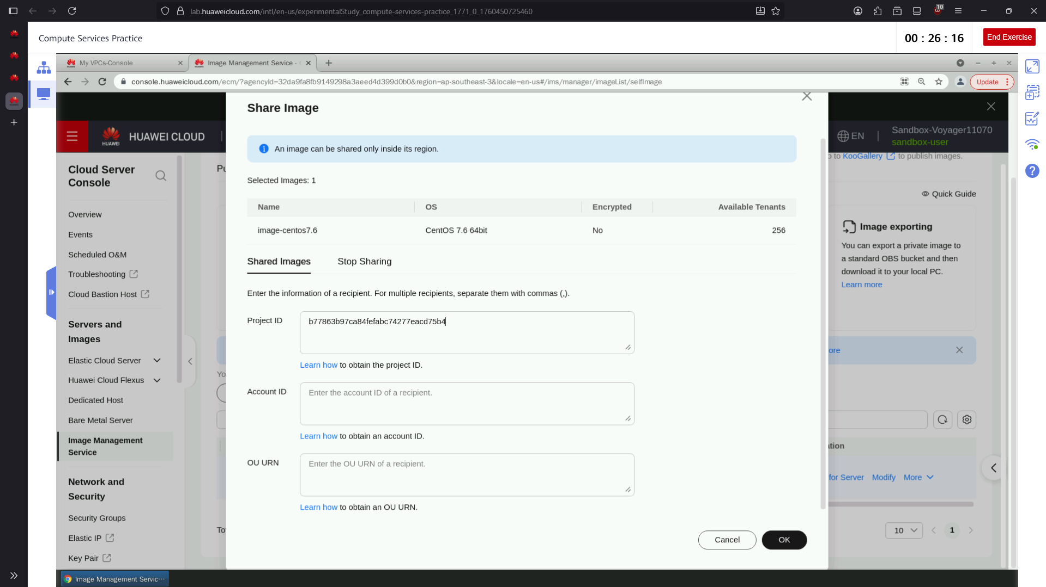


Main Account
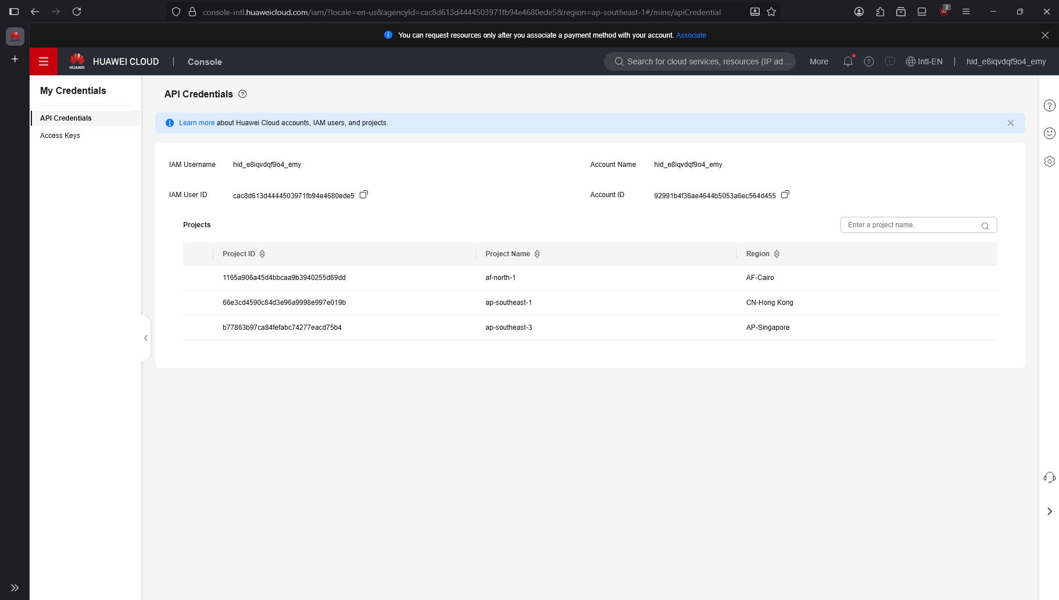

Sharing image from SandBox

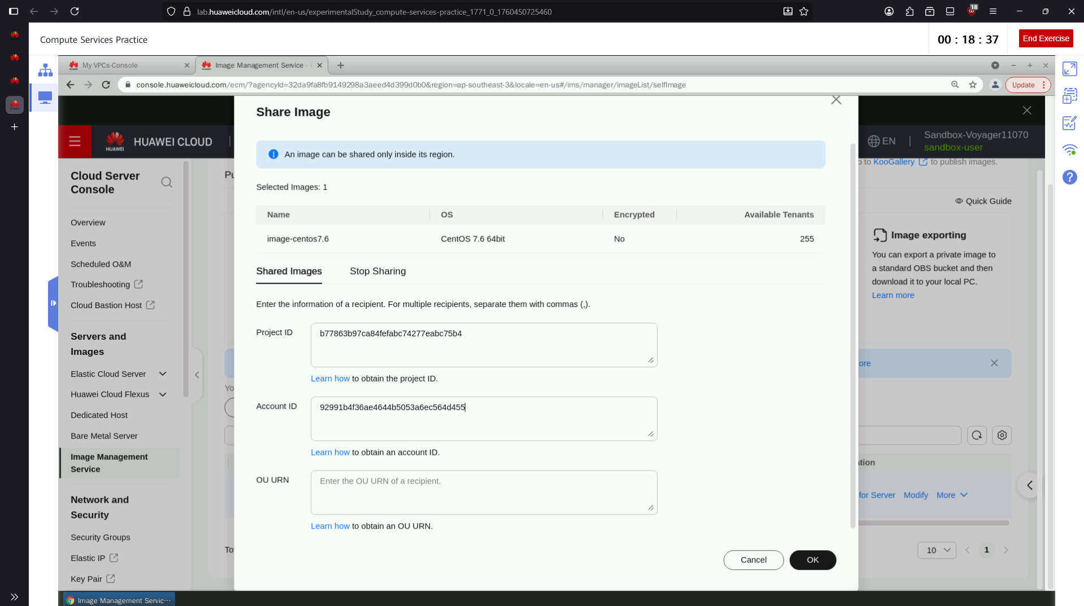

The Image Management Service helps users efficiently store, organize, and manage their images in the cloud. It provides quick and convenient access to images while allowing easy sharing without the worry of storage limitations or missing files. This service also improves productivity by enabling images to be edited, optimized, and distributed automatically. Through these features, it saves time, enhances workflow efficiency, and ensures that images remain secure and well-managed at all times.

